**Designing the program**

Before beginning the development of the program, I need to design some algorithms and pseudocode.

Here is a basic flow chart outlining the program structure:

GUI Components

Process User input to request from Database

User chosen topic

Entered into TextField

Process Data from Database into Questions on GUI Frame

Fetch appropriate questions and answers

Database

Multiple Choice

Checkboxgroup

Long Answer or Multiple Choice?

Long Answer

Text Field

Start

Is answer correct?

Check Answer

Yes

No

Yes

No

End

Go again?

Yes or No buttons

Go again?

Show which questions were wrong and what to revise

Display total marks

Yes

No

Is this the last question?

This needs to be revised

Add marks to score

In this program, some of the key algorithms are centred on the program interfacing with the database. This will be done using PHP incorporated in the java code. One such algorithm is getting the questions from the database according to topic. To represent the programs, they will have to be used as classes and methods, similarly to object oriented programming.

e.g.

Class Question

Method getQuestion

User inputs topic x

Query: All questions with topic x

New Question = question1

New Question = question2

Etc.

Then,

Method displayQuestion

Long answer:

Label = question

TextField = user’s answer

Multiple Choice:

Label = question

Checkboxgroup = user’s answer

It will return an answer to be checked with the mark scheme. In the case of a long answer question, the mark scheme will be shown to the user for them to check themselves and enter their score into a textfield.

The user interface is an important part of the design as it enables the user to use the program efficiently and with ease.

Here are the initial designs for the UI.

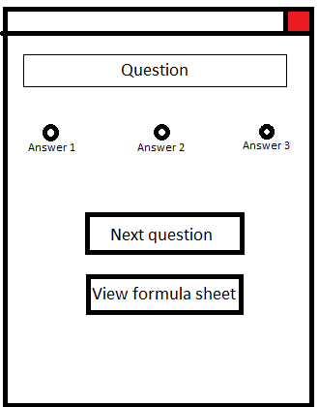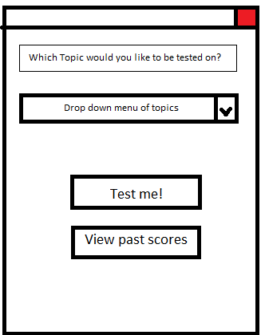

CheckboxGroup

Will open a pdf with the formula sheet

Multiple choice question layout

Main menu, where the user chooses their topic

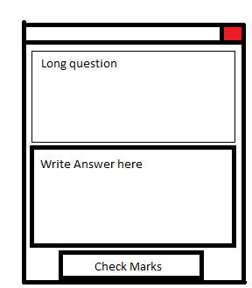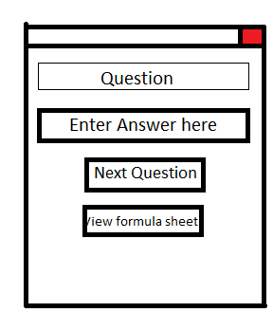

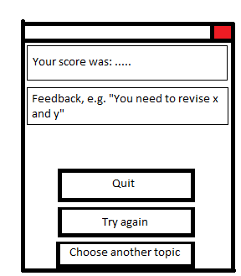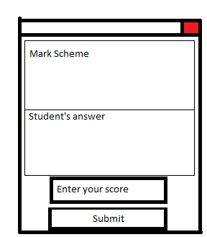

Goes back to menu

Will re-run the test

Closes application

Once the test has finished

Worded answer question, clicking check marks opens the mark scheme

One word answer question layout